**EX.NO:7 DATE: 2.02.2025**

**EDGE DETECTION TECHNIQUES**

**Aim:**  
To apply edge detection using techniques like Canny, Prewitt and Robert.

**Algorithm:**

1. Canny Edge Detection

* Gaussian Blur: Apply Gaussian blur to the input image to reduce noise using a Gaussian kernel.
* Compute Gradients: Compute the gradient magnitude and orientation using Sobel kernels. The code supports kernel sizes of 3 or 5.
* Non-Maximum Suppression: Suppress non-maximum pixel values to thin out edges.
* Edge Tracking by Hysteresis: Track edges by hysteresis using a double threshold.

2. Prewitt Edge Detection

* Apply Prewitt Operator: Convolve the image with Prewitt operator masks in both horizontal (Mx) and vertical (My) directions.
* Calculate Gradient Magnitude: Compute the gradient magnitude using the formula sqrt(Gx^2 + Gy^2).
* Thresholding: Apply a threshold value to the gradient magnitude.
* Binarization: Binarize the image based on the thresholded values to produce a final edge map.

3. Roberts Cross Edge Detection

* Apply Roberts Cross Operator: Convolve the image with Roberts Cross kernels (kernel_x and kernel_y).
* Calculate Gradient Magnitude: Compute the gradient magnitude using the formula sqrt(Gx^2 + Gy^2).
* Normalization: Normalize the resulting image to a 0-255 range for proper display.

**Code:**

import cv2  
import numpy as np  
from PIL import Image  
import matplotlib.pyplot as plt

image = cv2.imread('lena.jpg',0)  
plt.imshow(image, cmap='gray')  
plt.title("Original Image")

Text(0.5, 1.0, 'Original Image')

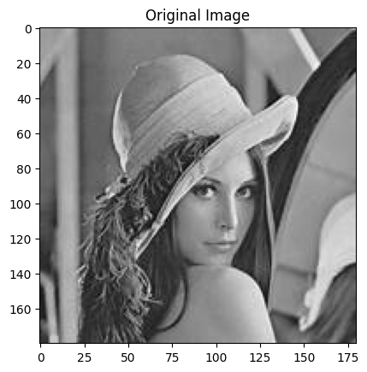

def apply_gaussian_blur(image, kernel_size):  
 def gaussian_kernel(size, sigma):  
 kernel = np.fromfunction(  
 lambda x, y: (1/ (2 * np.pi * sigma ** 2)) *   
 np.exp(- ((x - (size-1)/2) ** 2 + (y - (size-1)/2) ** 2) / (2 * sigma ** 2)),  
 (size, size)  
 )  
 return kernel / np.sum(kernel)  
  
   
 if kernel_size % 2 == 0:  
 kernel_size += 1  
  
   
 kernel = gaussian_kernel(kernel_size, sigma=1.0)  
  
   
 rows, cols = image.shape  
  
   
 k_half = kernel_size // 2  
  
   
 output = np.zeros_like(image)   
  
 for i in range(k_half, rows - k_half):  
 for j in range(k_half, cols - k_half):  
 output[i, j] = np.sum(image[i - k_half: i + k_half + 1, j - k_half: j + k_half + 1] * kernel)  
  
 return output[k_half:rows-k_half, k_half:cols-k_half]

def compute_gradient_magnitude_and_orientation(image, sobel_kernel_size):  
  
 if sobel_kernel_size == 3:  
 sobel_x = np.array([[-1, 0, 1], [-2, 0, 2], [-1, 0, 1]])  
 sobel_y = np.array([[-1, -2, -1], [0, 0, 0], [1, 2, 1]])  
  
 elif sobel_kernel_size == 5:  
 sobel_x = np.array([[-1, -2, 0, 2, 1], [-2, -3, 0, 3, 2], [-3, -5, 0, 5, 3], [-2, -3, 0, 3, 2], [-1, -2, 0, 2, 1]])  
 sobel_y = np.array([[-1, -2, -3, -2, -1], [-2, -3, -5, -3, -2], [0, 0, 0, 0, 0], [2, 3, 5, 3, 2], [1, 2, 3, 2, 1]])  
 else:  
 sys.exit("Sobel kernel size should be 3 or 5!")  
  
 rows, cols = image.shape  
  
 gradient_x = np.zeros_like(image, dtype=np.float64)  
 gradient_y = np.zeros_like(image, dtype=np.float64)  
  
 half_size = sobel_kernel_size // 2  
 for i in range(half_size, rows - half_size):  
 for j in range(half_size, cols - half_size):  
 window = image[i - half_size:i + half_size + 1, j - half_size:j + half_size + 1]  
 gradient_x[i, j] = np.sum(window * sobel_x)  
 gradient_y[i, j] = np.sum(window * sobel_y)  
  
 magnitude = np.sqrt(gradient_x ** 2 + gradient_y ** 2)  
   
 orientation = np.arctan2(gradient_y, gradient_x)  
  
 return magnitude, orientation

def apply_non_max_suppression(magnitude, orientation):  
 suppressed_magnitude = np.copy(magnitude)  
 rows, cols = magnitude.shape  
   
 for i in range(1, rows - 1):  
 for j in range(1, cols - 1):  
 angle = orientation[i][j]  
 q = [0, 0]  
 if (-np.pi/8 <= angle < np.pi/8) or (7*np.pi/8 <= angle):  
 q[0] = magnitude[i][j+1]  
 q[1] = magnitude[i][j-1]  
 elif (np.pi/8 <= angle < 3*np.pi/8):  
 q[0] = magnitude[i+1][j+1]  
 q[1] = magnitude[i-1][j-1]  
 elif (3*np.pi/8 <= angle < 5*np.pi/8):  
 q[0] = magnitude[i+1][j]  
 q[1] = magnitude[i-1][j]  
 else:  
 q[0] = magnitude[i-1][j+1]  
 q[1] = magnitude[i+1][j-1]  
   
 if magnitude[i][j] < max(q[0], q[1]):  
 suppressed_magnitude[i][j] = 0  
   
 return suppressed_magnitude

def apply_edge_tracking_by_hysteresis(magnitude, low_threshold, high_threshold):  
 rows, cols = magnitude.shape  
 edge_map = np.zeros((rows, cols), dtype=np.uint8)  
   
 strong_edge_i, strong_edge_j = np.where(magnitude >= high_threshold)  
 weak_edge_i, weak_edge_j = np.where((magnitude >= low_threshold) & (magnitude < high_threshold))  
   
 edge_map[strong_edge_i, strong_edge_j] = 255  
  
 for i, j in zip(weak_edge_i, weak_edge_j):  
 if (edge_map[i-1:i+2, j-1:j+2] == 255).any():  
 edge_map[i, j] = 255  
   
 return edge_map

smoothed_image = apply_gaussian_blur(image, 5)  
  
magnitude, orientation = compute_gradient_magnitude_and_orientation(smoothed_image, 3)  
  
mx = apply_non_max_suppression(magnitude, orientation)  
  
low_threshold, high_threshold = 70, 100  
emap = apply_edge_tracking_by_hysteresis(mx, low_threshold, high_threshold)  
  
plt.figure(figsize=(10,6))  
plt.subplot(1,2,1)  
plt.imshow(image,cmap='gray')  
plt.title("Original Image")  
plt.subplot(1,2,2)  
plt.imshow(emap, cmap='gray')  
plt.title("Canny Image")

Text(0.5, 1.0, 'Canny Image')

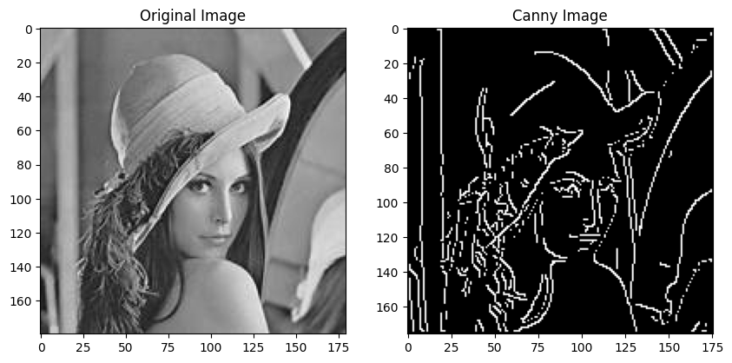

image = cv2.imread("download.jpeg", 0)  
smoothed_image = apply_gaussian_blur(image, 5)  
  
magnitude, orientation = compute_gradient_magnitude_and_orientation(smoothed_image, 3)  
  
mx = apply_non_max_suppression(magnitude, orientation)  
  
low_threshold, high_threshold = 125, 200  
emap = apply_edge_tracking_by_hysteresis(mx, low_threshold, high_threshold)  
  
plt.figure(figsize=(10,6))  
plt.subplot(1,2,1)  
plt.imshow(image,cmap='gray')  
plt.title("Original Image")  
plt.subplot(1,2,2)  
plt.imshow(emap, cmap='gray')  
plt.title("Canny Image")

Text(0.5, 1.0, 'Canny Image')

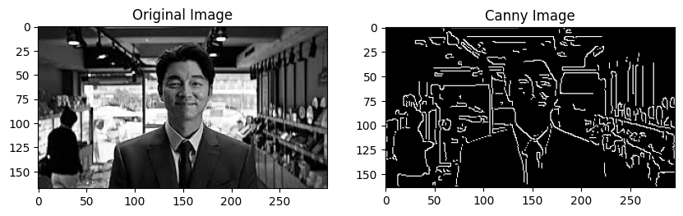

def apply_prewitt_edge_detection(input_image):  
   
 input_image = input_image.astype(np.float64)  
   
   
 filtered_image = np.zeros(input_image.shape)  
   
 Mx = np.array([-1, 0, 1, -1, 0, 1, -1, 0, 1]).reshape(3, 3)  
 My = np.array([-1, -1, -1, 0, 0, 0, 1, 1, 1]).reshape(3, 3)  
   
 for i in range(1, input_image.shape[0] - 1):  
 for j in range(1, input_image.shape[1] - 1):  
   
 Gx = np.sum(Mx * input_image[i-1:i+2, j-1:j+2])  
 Gy = np.sum(My * input_image[i-1:i+2, j-1:j+2])  
   
 filtered_image[i, j] = np.sqrt(Gx**2 + Gy**2)  
   
 filtered_image = (filtered_image / filtered_image.max() * 255).astype(np.uint8)  
 plt.figure(figsize=(8, 6))  
 plt.imshow(filtered_image, cmap='gray')  
 plt.title('Filtered Image')  
 plt.show()  
   
 threshold_value = 100 # varies between [0 255]  
 output_image = np.maximum(filtered_image, threshold_value)  
 output_image[output_image == threshold_value] = 0  
 output_image = (output_image > 0).astype(np.uint8) * 255  
   
 plt.figure(figsize=(8, 6))  
 plt.imshow(output_image, cmap='gray')  
 plt.title('Edge Detected Image')  
 plt.show()  
   
input_image = np.array(Image.open('download.jpeg').convert('L'))  
  
apply_prewitt_edge_detection(input_image)

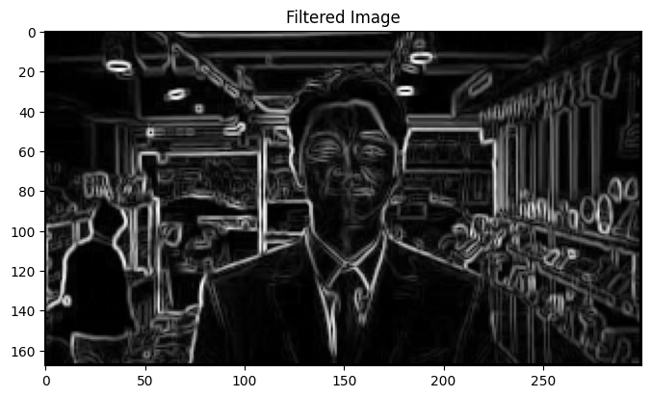

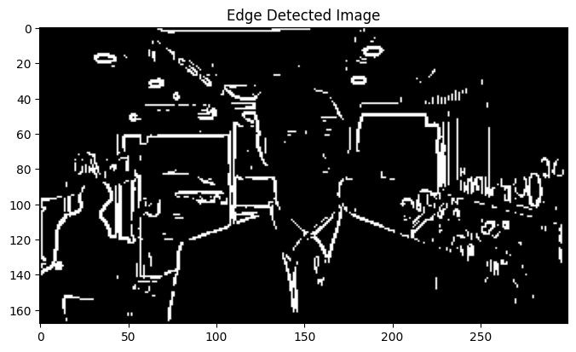

def roberts_cross_edge_detection(input_image):  
 if len(input_image.shape) == 3:  
 input_image = np.mean(input_image, axis=2).astype(np.uint8)  
   
 kernel_x = np.array([[1, 0], [0, -1]])  
 kernel_y = np.array([[0, 1], [-1, 0]])  
   
 output_image = np.zeros(input_image.shape)  
   
 for i in range(1, input_image.shape[0] - 1):  
 for j in range(1, input_image.shape[1] - 1):  
 patch = input_image[i-1:i+1, j-1:j+1]  
 Gx = np.sum(patch * kernel_x)  
 Gy = np.sum(patch * kernel_y)  
 output_image[i, j] = np.sqrt(Gx**2 + Gy**2)  
   
 output_image = (output_image / output_image.max() * 255).astype(np.uint8)  
   
 return output_image  
  
input_image = np.array(Image.open('download.jpeg'))  
output_image = roberts_cross_edge_detection(input_image)  
  
plt.figure(figsize=(12, 6))  
plt.subplot(1, 2, 1)  
plt.imshow(input_image, cmap='gray')  
plt.title('Original Image')  
plt.axis('off')  
  
plt.subplot(1, 2, 2)  
plt.imshow(output_image, cmap='gray')  
plt.title('Edges Detected by Roberts Cross')  
plt.axis('off')  
  
plt.show()

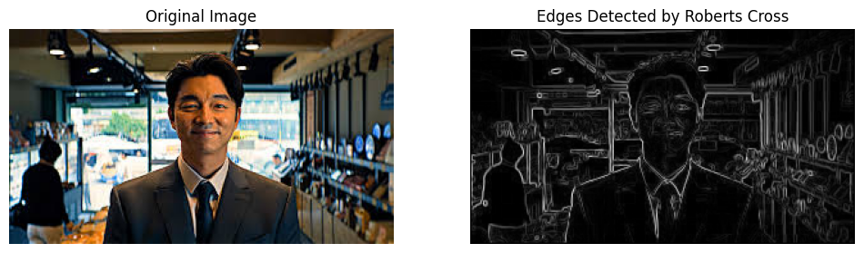

**Inference:** The algorithms identify edges by detecting changes in pixel intensity. Higher gradient magnitudes correspond to stronger edge presence. Thresholding helps to isolate prominent edges.

**Result:** The output images highlight the detected edges, effectively representing boundaries and contours within the original image.